Team: Cocomo

Machine Learning Debugging, Gradients & Evaluation
Colab notebook: Issue1_Executed.ipynb(Yes, I have used AI to code, but test me about the approaches. I have explicitly told what to do to AI)

Milestone 1 — Bugs and fixes
The fixes below follow the original code order. Where the snippet leaves out a helper or the data setup, I have marked the issue as conditional.
1. StandardScaler fitted before splitting
The scaler sees the validation rows before training starts. That leaks information from the holdout and can make validation look better than it should. Split first, fit on training rows, then reuse that scaler for validation.
from sklearn.preprocessing import StandardScaler

X_tr, X_val = X[:8000], X[8000:]
y_tr, y_val = y[:8000], y[8000:]
scaler = StandardScaler()
X_tr = scaler.fit_transform(X_tr)
X_val = scaler.transform(X_val)
2. Slicing may produce an unsuitable split (conditional)
If rows are sorted by class or source, taking the last 2,000 rows can create a very different validation set. For independent rows, use a stratified split before scaling:
from sklearn.model_selection import train_test_split

X_tr, X_val, y_tr, y_val = train_test_split(
X, y, test_size=0.2, stratify=y, random_state=42
)
For time-dependent or related records, use a chronological or grouped split that matches how the model will be used.
3. Features shuffled without labels
Shuffling X_tr alone pairs each row with the wrong label. A model can still memorize those pairs and lower training loss while validation stays near its baseline. Shuffle features and labels together before building the loader.
from sklearn.utils import shuffle

X_tr, y_tr = shuffle(X_tr, y_tr, random_state=42)
4. BatchNorm fails on a singleton training batch (conditional)
BatchNorm cannot train on a batch containing only one row. drop_last=True prevents an incomplete final batch; with 8,000 rows and batch size 64, no rows are dropped.
from torch.utils.data import DataLoader, TensorDataset

train_dataset = TensorDataset(
torch.as_tensor(X_tr, dtype=torch.float32),
torch.as_tensor(y_tr, dtype=torch.long)
)
train_loader = DataLoader(
train_dataset, batch_size=64, shuffle=True, drop_last=True
)
5. Loss/target mismatch (conditional)
The snippet does not show loss_fn. With two output logits and class labels 0 or 1, CrossEntropyLoss and integer targets are a suitable choice. A different loss needs a matching output and target format.
loss_fn = nn.CrossEntropyLoss()
# Inside the training loop:
yb = yb.long()
6. Scheduler stepped after every batch
With this StepLR setup, stepping after every batch shrinks the learning rate far too quickly. Move scheduler.step() outside the batch loop so it runs once per epoch:
for epoch in range(50):
model.train()
for xb, yb in train_loader:
# forward, zero_grad, backward, optimizer step
...
scheduler.step()
7. Validation
- Without eval(), dropout stays active, so validation predictions change between calls. BatchNorm also uses validation-batch statistics and updates its running state.
- Without no_grad(), validation builds computation graphs it never uses, adding memory and computation costs.
- Dtype/device mismatch (conditional): StandardScaler commonly returns float64, while the model normally uses float32. Validation inputs must also be on the model's device; a mismatch raises a runtime error.
- Accuracy helper (conditional): the helper is not shown. For two logits, select the larger logit with argmax and compare its class index with the true label.
device = next(model.parameters()).device
xv = torch.as_tensor(X_val, dtype=torch.float32, device=device)
yv = torch.as_tensor(y_val, dtype=torch.long, device=device)

model.eval()
with torch.no_grad():
val_logits = model(xv)
val_acc = (val_logits.argmax(dim=1) == yv).float().mean().item()
print(epoch, val_acc)

Quick checks without source-code access
- Repeat identical predictions. Keep the model version fixed and send the same batch about 20 times. Compare scores as well as labels: labels can stay the same while probabilities change. Variation can reveal dropout, random preprocessing or nondeterministic inference. BatchNorm by itself gives the same result for an identical batch.
- Change batch companions. Keep a few target rows fixed, but change the other rows in their batch and the batch size. If the target scores change substantially, suspect training-mode BatchNorm or batch-dependent preprocessing. BatchNorm uses the batch mean and variance, so other rows can affect the same target. Tiny rounding differences are expected.
- Recalculate the metric. Use returned predictions and trusted labels to calculate accuracy, the confusion matrix and per-class recall yourself. Compare with the majority-class baseline. Mostly predicting one class suggests class collapse. A mismatch with reported accuracy suggests a scoring, row-order or class-mapping problem.
- Try a tiny verified set. Retrain a fresh model on 50–100 checked examples with less regularization, then score those same rows. If it cannot fit them, check feature-label pairing, the loss, input quality and optimizer updates. An easy dataset with a known signal can test the wider pipeline. Passing this test does not prove that the real validation set is representative.
- Shuffle training labels only. Keep validation labels fixed, start a fresh model and repeat several times. Strong validation performance after removing the training signal raises suspicion of leakage, overlapping records or scoring the wrong rows. Compare with an appropriate baseline and allow for sampling variation.
- Request a learning-rate trace. With batch size 64, 8,000 rows give 125 batches. Batch-wise decay leaves 0.001×0.9^125 ≈ 1.91e-9 after one epoch; epoch-wise decay leaves 9e-4. Ask the operator for LR values after a few batches and at epoch boundaries. Prediction access alone cannot expose the scheduler.
The first two checks need only prediction access. The others need trusted labels, a retraining interface or help from the operator; none requires reading the source code.

Milestone 2 — Attention gradients and verification
1. Derivation
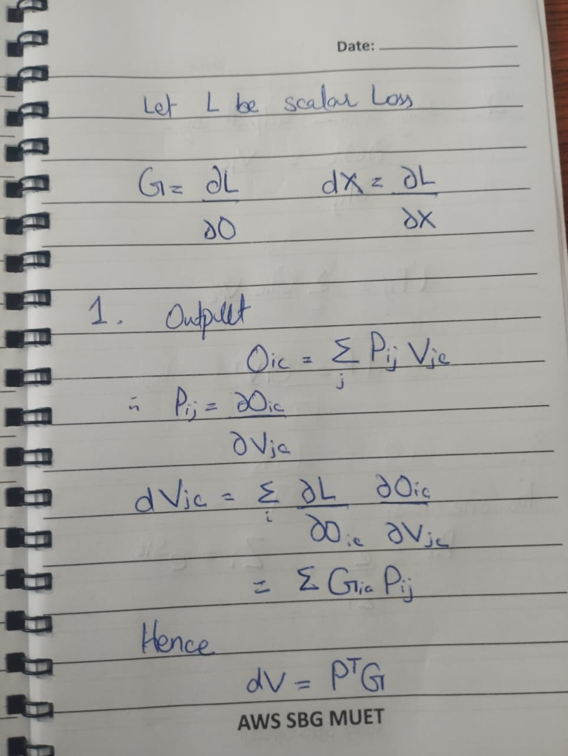

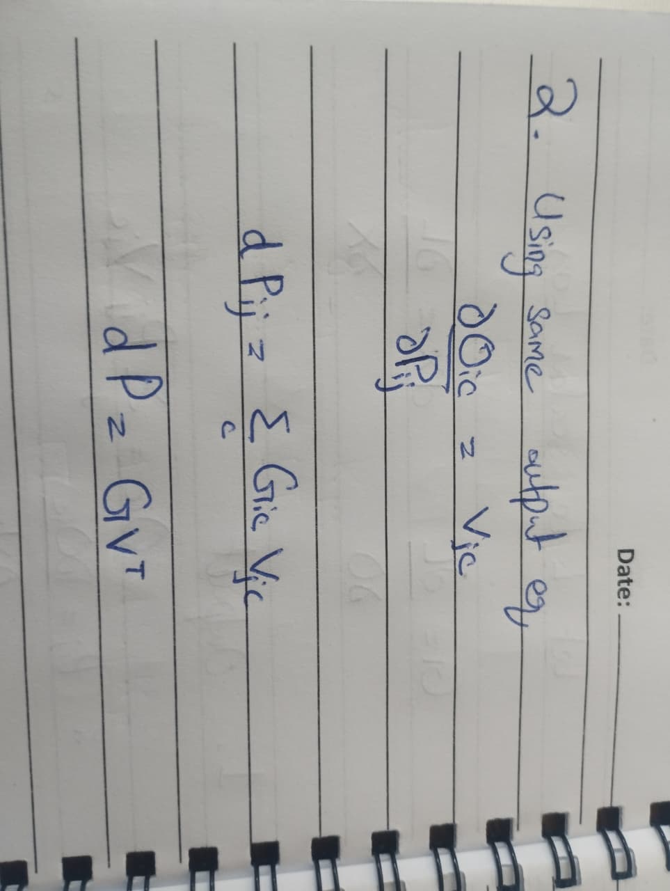

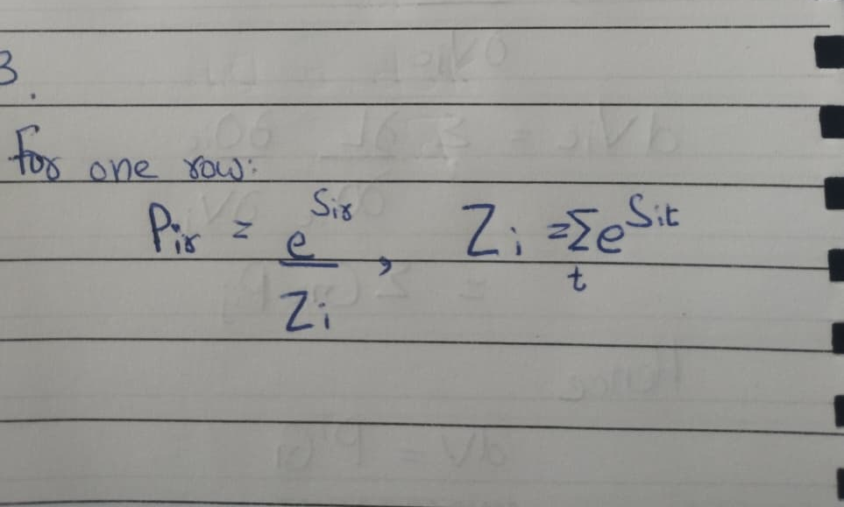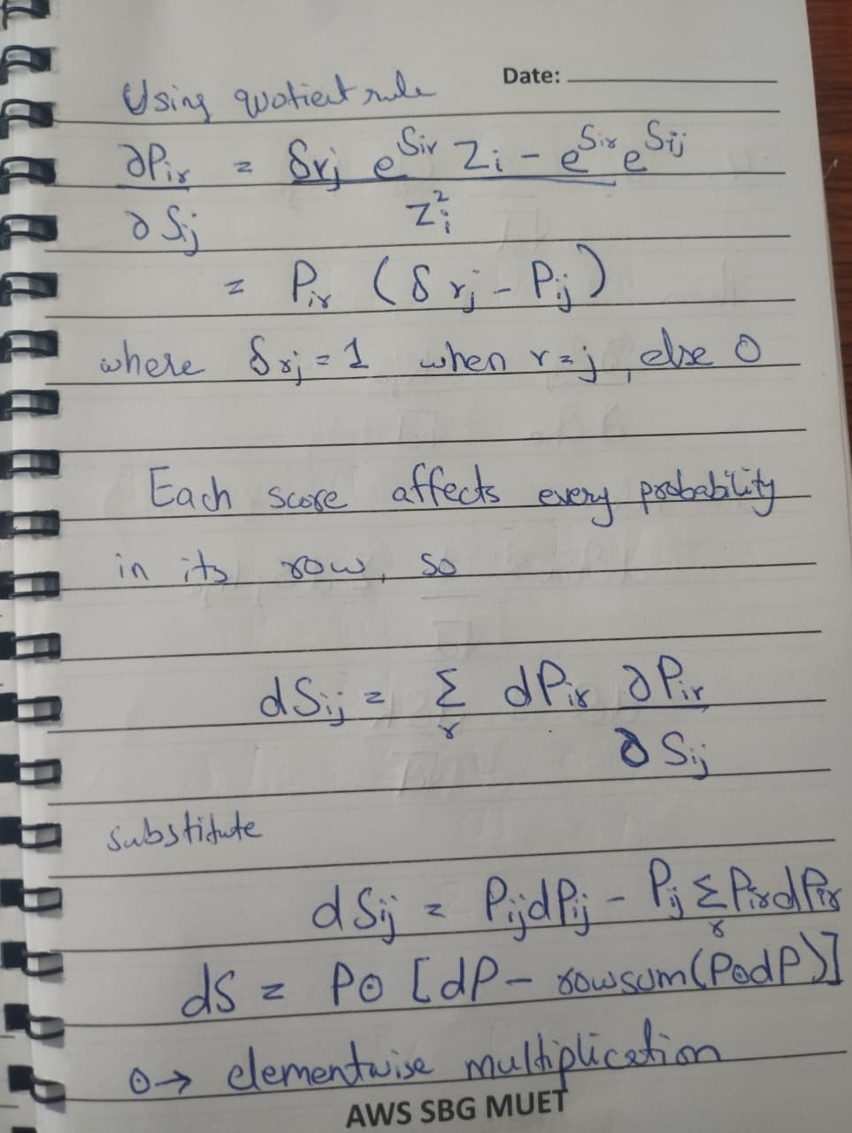
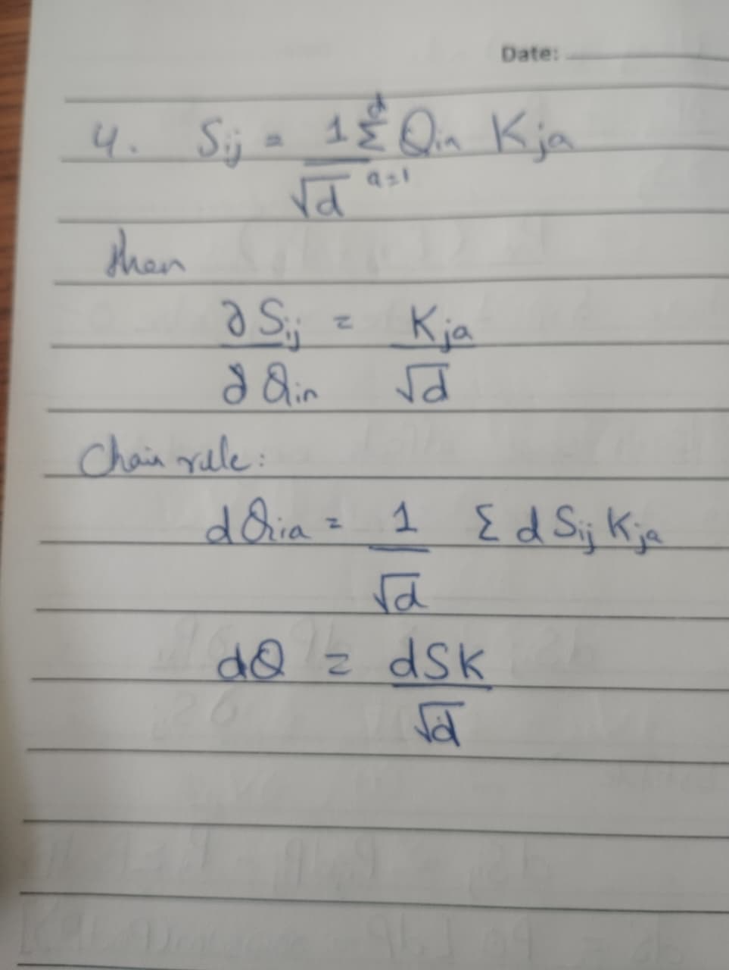
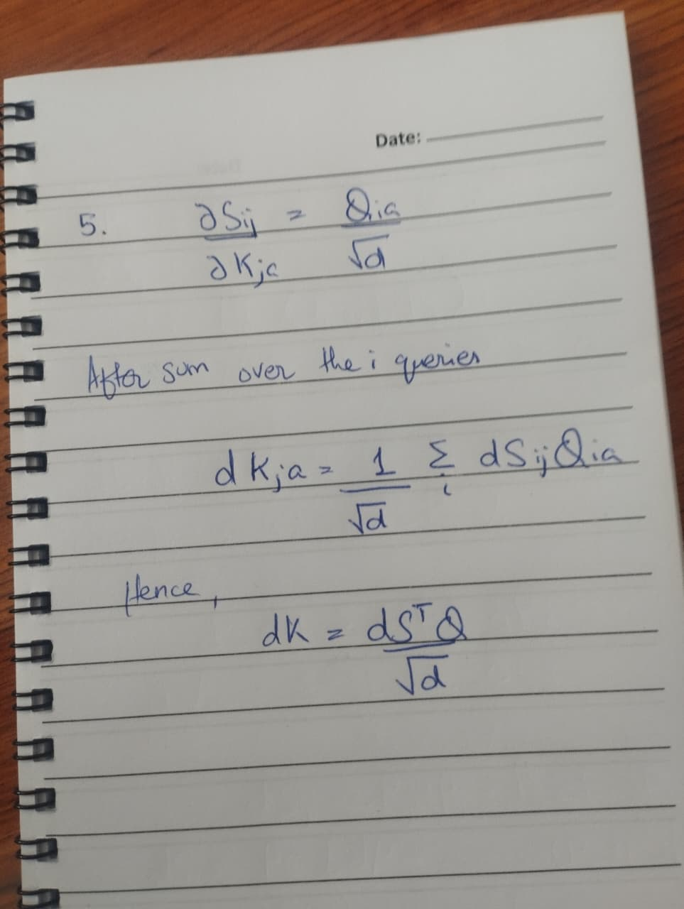
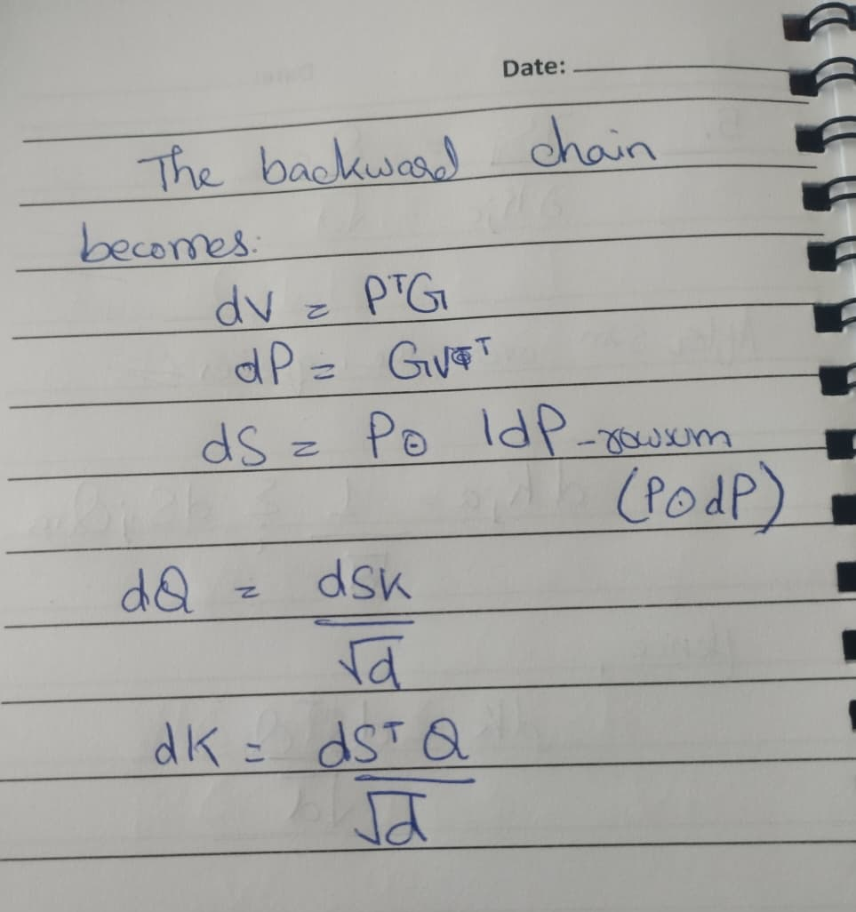

Here G=dO. The feature sum in the score equation is S_ij = sum_a(Q_ia K_ja)/sqrt(d). The handwritten pages above derive all five gradients.
Q2. Implement NumPy forward and backward and verify the gradients.
I check the backward pass against central differences on the scalar loss L=sum(O*dO), keeping dO fixed. The code uses float64 and a main step size of 1e-5, with extra checks at 1e-4 and 1e-6. A check passes only if it meets absolute tolerance 1e-7, relative tolerance 1e-5 and normalized L2 error at most 1e-7. The notebook contains the full NumPy forward/backward code and the checker.
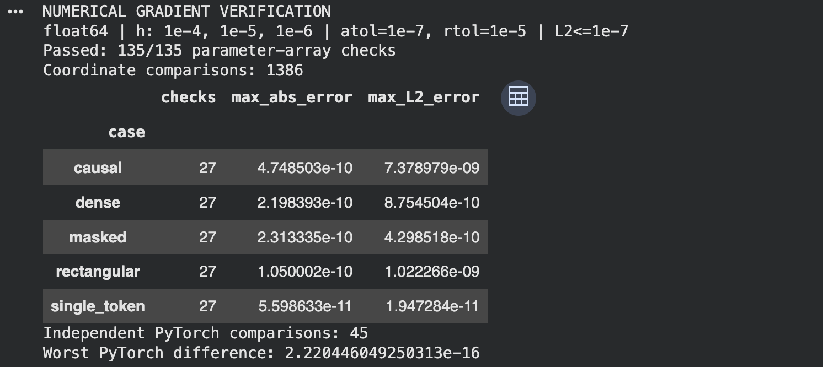
Q3. What numerical stability issue occurs in forward, and how is it fixed?
Large positive scores can overflow when exponentiated. Large negative scores can all underflow to zero, leaving a zero denominator. Subtract the maximum score in each row before taking exp. This leaves softmax probabilities unchanged and ensures that at least one exponent equals 1, provided the row has a finite, unmasked score. The screenshot checks finite outputs, row sums and invariance to a constant shift.
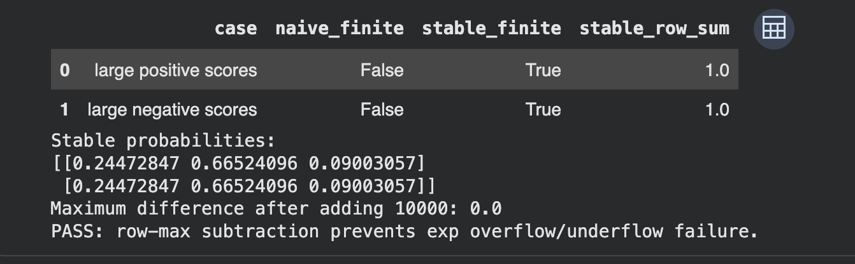
Q4. Why use the scaling factor 1/sqrt(d)?
A dot product adds d terms. If Q and K have independent, zero-mean, unit-variance components, its variance grows with d. Dividing by sqrt(d) keeps the score variance near 1. This helps prevent softmax from becoming almost one-hot, where most score gradients become very small. The table tests this with controlled random inputs; its Jacobian trace, 1-sum(p²), measures softmax sensitivity rather than a task-loss gradient.
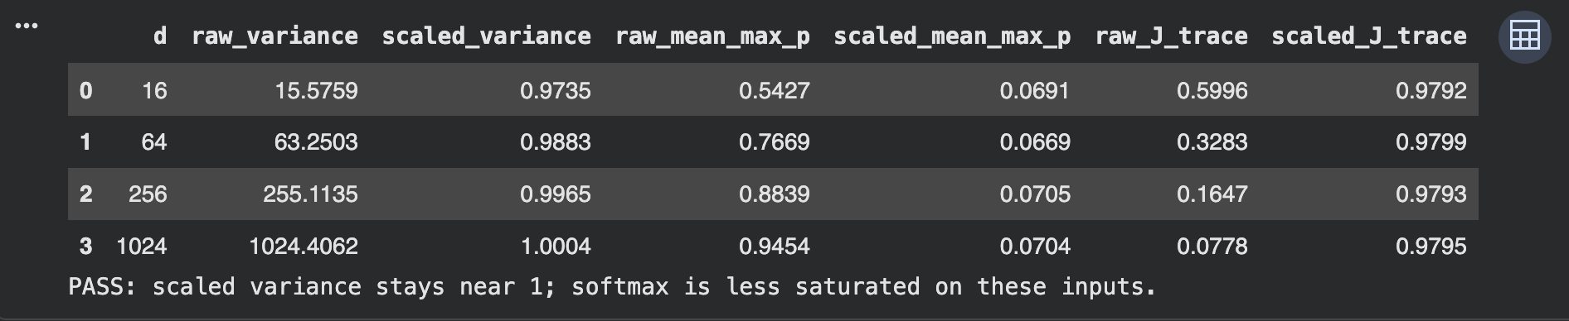
Q5. How does backward change with a causal mask?
A causal mask sets future scores to negative infinity before softmax. Those positions get probability zero and dS=0. The remaining backward equations stay the same. In this experiment, only earlier query outputs contribute to the loss, so future K and V also get zero gradients. Later queries could still send gradients to those positions if their outputs contributed to the loss.
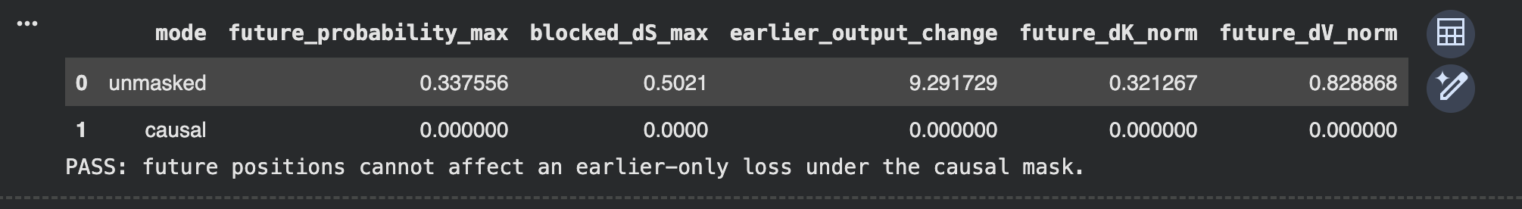
Q6. How does memory grow, and how does FlashAttention avoid it?
For one attention head, S and P each contain n² values. In float32, storing both takes 8n² bytes, so doubling n uses four times as much memory. Inputs and outputs also take O(nd+nd_v) space. The first table checks the dense storage; the second compares dense attention with a tiled NumPy implementation. Its peak values track Python/NumPy allocations, excluding inputs created before tracing.
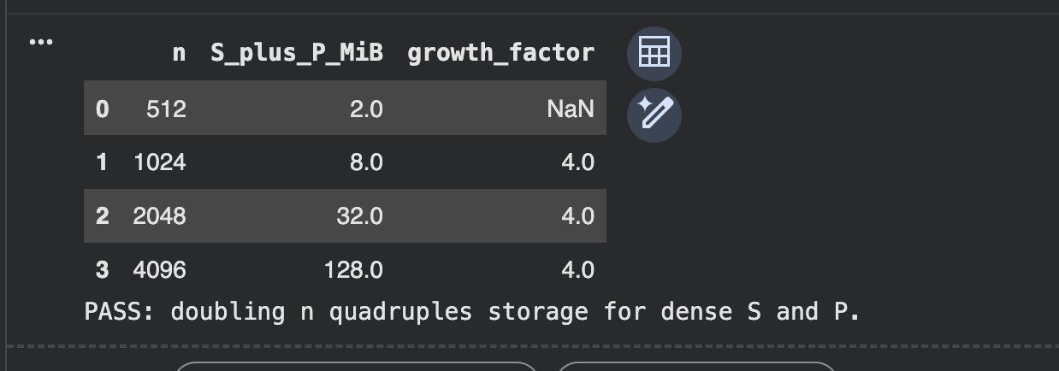
First-row growth is N/A because there is no previous measurement to compare with.
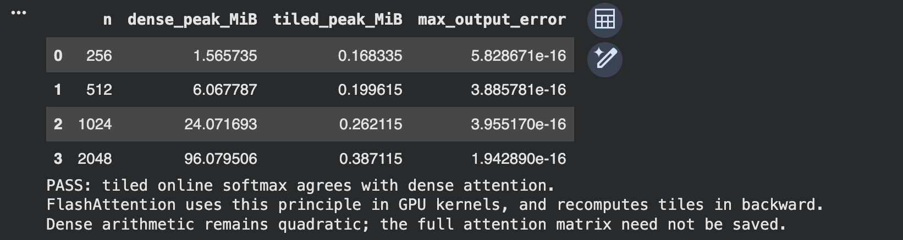FlashAttention processes attention in tiles and uses online softmax, so it does not write the full n×n score/probability matrices to GPU memory. It saves row statistics and recomputes tiles during backward. For fixed head dimensions, this makes saved attention activation memory grow linearly with n; dense attention computation still grows quadratically. The CPU tiled test demonstrates this idea, not the actual CUDA kernel. The optional GPU benchmark is separate.

Milestone 3 Fraud evaluation
Q1. Which metrics should compare models?
I would compare models using average precision/PR curves, recall at a fixed review budget or false-positive rate, precision among alerts and expected cost. Report prevalence and uncertainty with the results. Accuracy is misleading here: predicting every transaction legitimate already scores 99.9%. ROC-AUC can hide an impractical number of false alerts, so I would use it as a secondary metric. F1 also ignores the stated $200/$5 costs.
Q2. How should train validation and test be split?
Train on older transactions, validate on a later period and keep the newest test period untouched. Repeat this at several historical cutoffs to see whether results hold over time. At each training time T, use only labels that had arrived by T; a 60-day transaction-age cutoff is conservative if labels are complete by then. Build features using information available at transaction time. Use separate matured development periods for calibration and threshold choice. Fix the model before its test window begins, wait for test labels and prevent duplicate transactions or shared outcomes from leaking across splits.
Q3. How can evaluation work with delayed labels?
Log each transaction's time, model version, score, action and label-arrival time. Evaluate cohorts once their 30–60-day label window has passed, checking that labels are complete. Keep pending outcomes unlabeled. Recent scores and alert rates can give early warnings, but they cannot establish recall. Reviewed alerts are a selected sample; use representative audits or justified weighting. Blocked transactions also need care because the chargeback that would have happened may never be observed.
Q4. What threshold minimizes the stated cost and how is calibration checked?
Let $p$ be a calibrated fraud probability. Allowing the transaction has expected cost $200p$; flagging it has expected cost $5(1-p)$. Flag when $5(1-p)<200p$, giving a threshold of 5/205-approx2.44%. This assumes correct decisions have zero cost and flagging prevents the fraud loss.
I compared candidate thresholds in a synthetic demonstration with an expected fraud prevalence of 0.1%. Scores were calibrated by construction, and independent validation and test cohorts each contained one million transactions. Thresholds were selected using validation data only.
The validation-selected threshold was 2.225%, with validation cost $175,775. On the independent test cohort, it cost $176,780, compared with $176,595 for the cost-derived threshold. This illustrates sampling variation: the lowest validation cost does not guarantee the lowest cost on another cohort. The theoretical boundary remains 2.44% under the stated assumptions; these synthetic results do not establish real-world performance.
For deployment, check calibration on matured, later-period data at natural prevalence. Transactions scored near 2.5% should have roughly that fraud rate. Inspect a reliability plot near the decision threshold, Brier score, log loss and calibration intercept/slope. Fit any recalibration on separate development data.

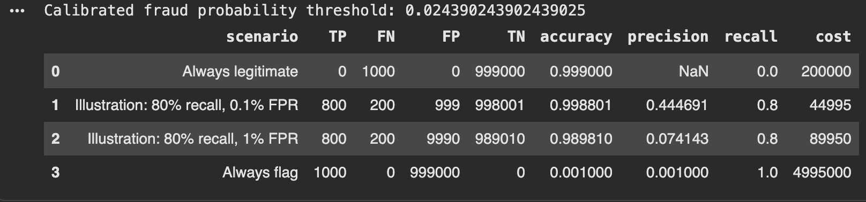
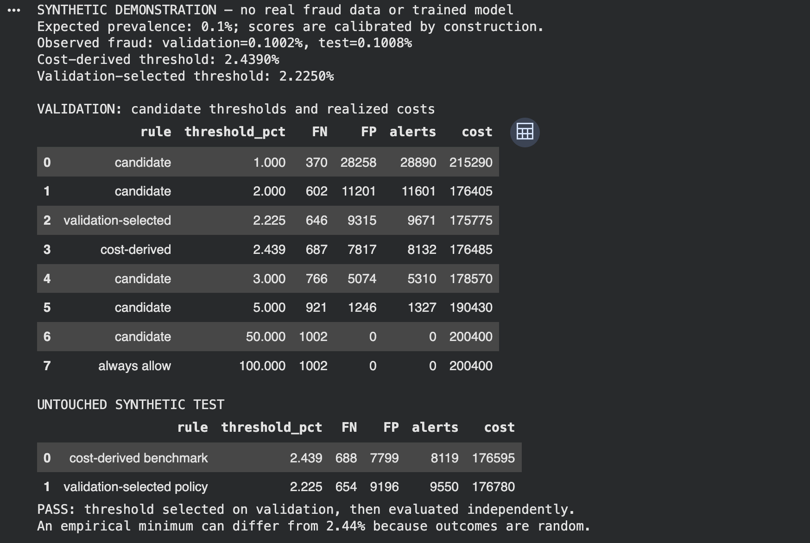
Q5. How should drift and retraining be handled?
Monitor missing values, schema changes, feature distributions, scores and alert rates. Compare changes with a reference period using effect sizes and tests such as KS, allowing for repeated comparisons. Once labels mature, track cost, recall at the operating review budget and calibration, including important segments. Set cost/recall limits in advance and act on a sustained breach across mature cohorts. If ranking still works but probabilities shift, recalibrate. If ranking or feature-outcome relationships worsen, retrain and test the challenger on later periods before replacing the current model.

Milestone 4 Learning curves
Q1. Diagnose A B and C and propose interventions.
A: Both scores are low and stay flat as data grows, which points first to underfitting. The model may lack useful features or capacity, be too heavily regularized, or fail to optimize. Check that it can fit a small verified set, then improve features, capacity or training settings. More rows alone are unlikely to fix this plateau; noisy labels are another possibility. Or in some scenarios it can also be considered that the model has reached ceiling.
B: The model fits training data almost perfectly but generalizes much less well. The slowly shrinking gap is consistent with overfitting. More representative, clean data may help; I would also try stronger regularization, a simpler model and early stopping. Check split quality and distribution differences before assuming model complexity is the only cause. Although the results are converging, but slowly.
C: Higher validation accuracy can happen when dropout or augmentation makes training harder, or when training accuracy averages predictions made before the final epoch checkpoint. Recompute both scores with the same frozen model, eval mode and comparable preprocessing. If the gap remains, compare class balance, difficulty, leakage and uncertainty before changing the model.
Q2. Give two explanations for D and one experiment to distinguish them.
D: A gap that remains after four times as much data could come from a train/validation distribution shift or different labeling rules. I would run one 2×2 experiment: same-source versus original cross-source splits, each using original versus independently adjudicated labels under one rubric. Match training sizes and class mix, and keep the model, training budget and seeds fixed. Compare the same records when changing their labels.
If a same-source split closes the gap even after label correction, that supports distribution shift. If consistent labels close it within both split types, that supports a labeling problem. Both effects may be present. Compare validation accuracy as well as the gap, and keep the deployment-relevant split for final evaluation. This is a proposed experiment because no Case D dataset was supplied.

